**Experiment No: 08**

**Aim:** To understand Docker Architecture and Container life cycle, Install Docker and execute Docker commands to manage images and interact with containers.

**Lab Outcome:** LO5-Explain concept of containerization and illustrate the containerization of OS images and deployment of applications over Docker.

**Theory:**

Docker is a software platform that allows you to build, test, and deploy applications quickly. Docker packages software into standardized units called [containers](https://aws.amazon.com/containers/) that have everything the software needs to run including libraries, system tools, code, and runtime. Using Docker, you can quickly deploy and scale applications into any environment and know your code will run. Running Docker on AWS provides developers and admins a highly reliable, low-cost way to build, ship, and run distributed applications at any scale.

Docker works by providing a standard way to run your code. Docker is an operating system for containers. Similar to how avirtual machin[e](https://aws.amazon.com/ec2/) virtualizes (removes the need to directly manage) server hardware, containers virtualize the operating system of a server. Docker is installed on each server and provides simple commands you can use to build, start, or stop containers.

AWS services such as [AWS Fargate,](https://aws.amazon.com/fargate/) [Amazon ECS,](https://aws.amazon.com/ecs/) [Amazon EKS,](https://aws.amazon.com/eks/) and [AWS Batch](https://aws.amazon.com/batch/) make it easy to run and manage Docker containers at scale.

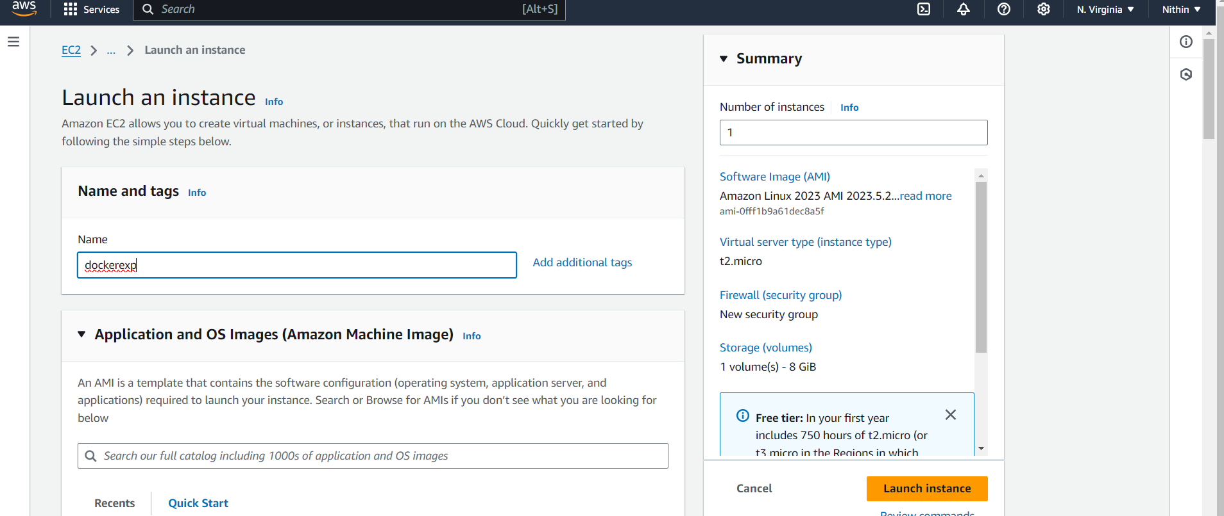

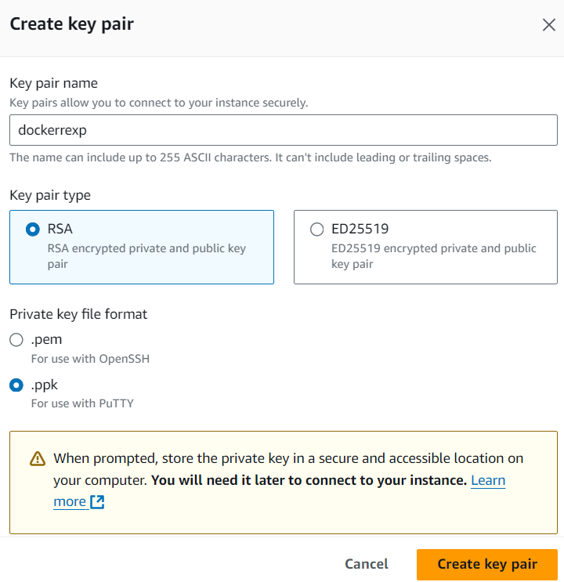

After launching the instance, copy the public ip and enter it into PuTTY

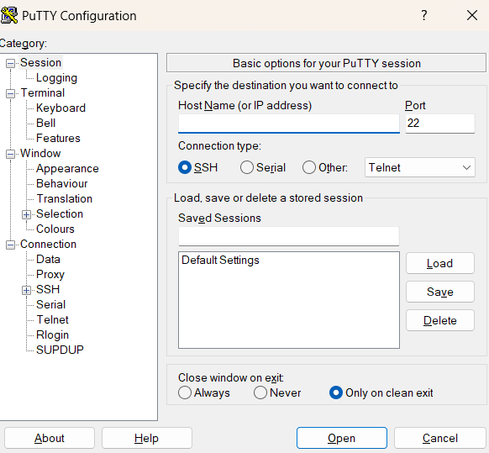

Then select SSH >Auth >Credentials and upload the file downloaded while creating the key value pair of instance

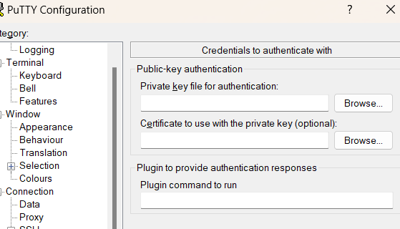

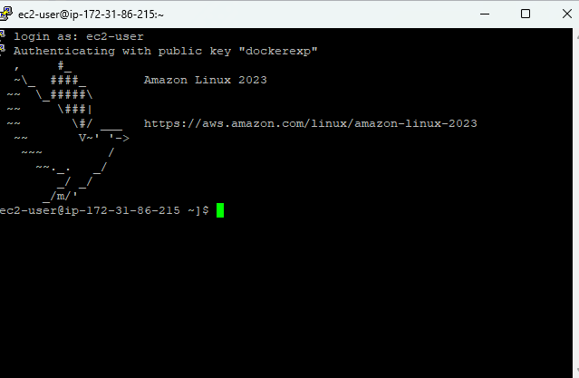

Sudo su

Yum update -y

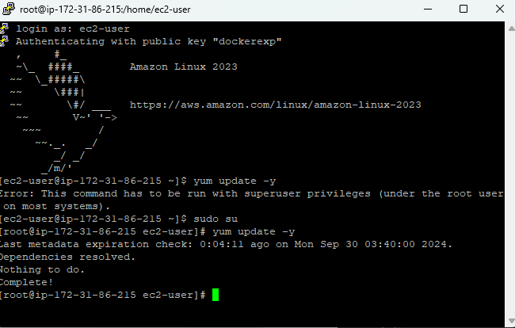

Yum install docker -y

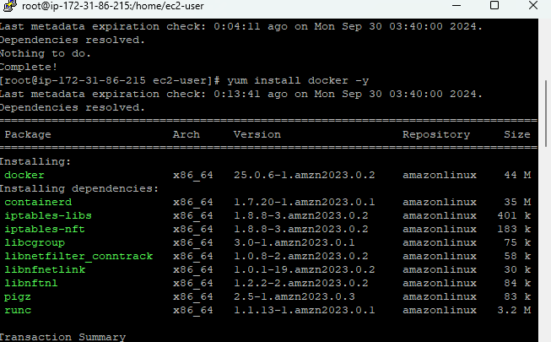

Service docker start

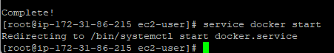

Sudo usermod -a -G docker ec2-user



Systemctl enable docker

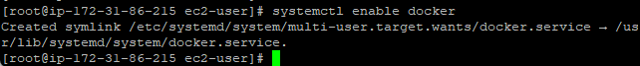

Service docker status

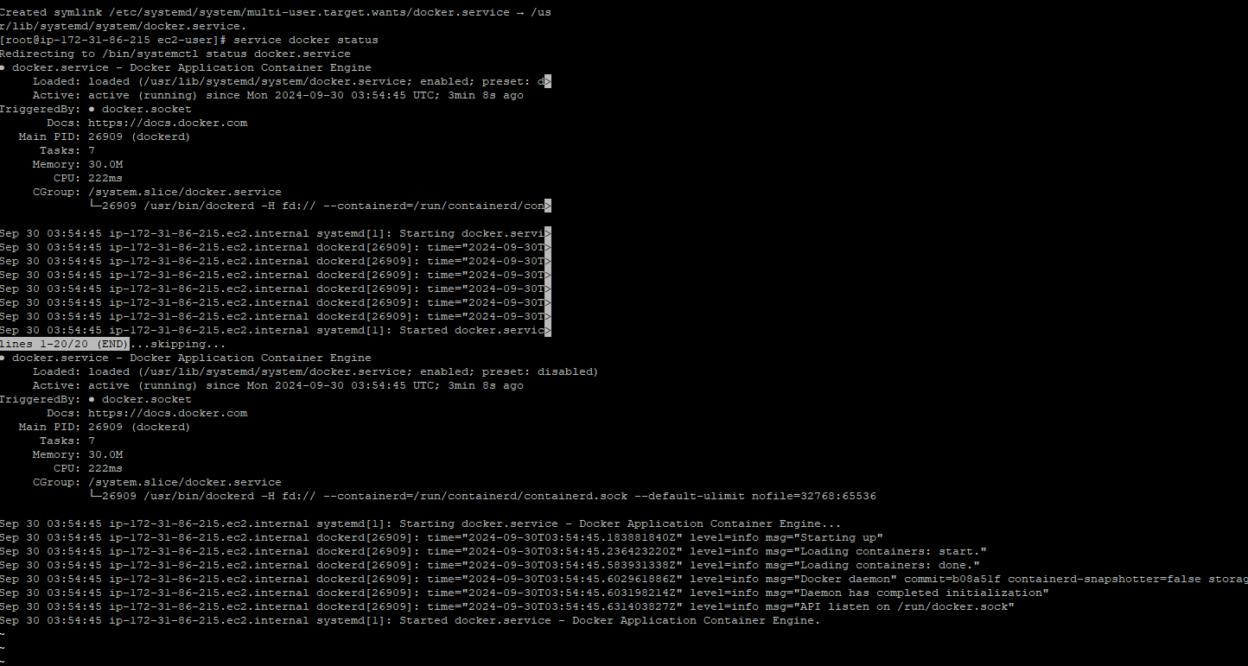

Docker info

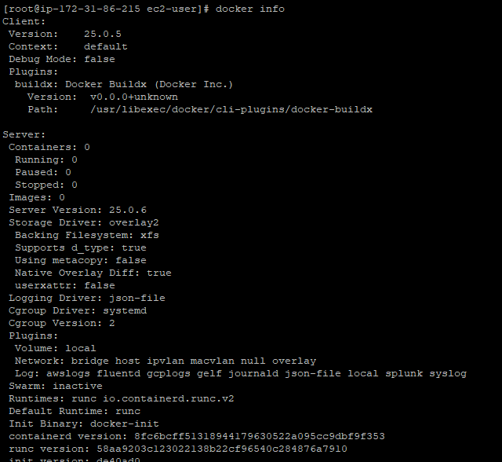

Docker images’



Docker pull ubuntu

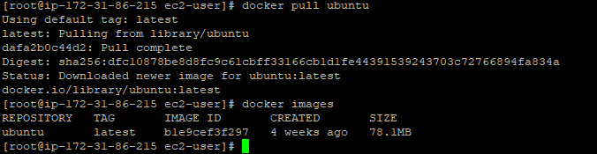

Docker run -it -d ubuntu



Docker ps



Docker ps -a



Docker exec -it <container id> bash



Exit



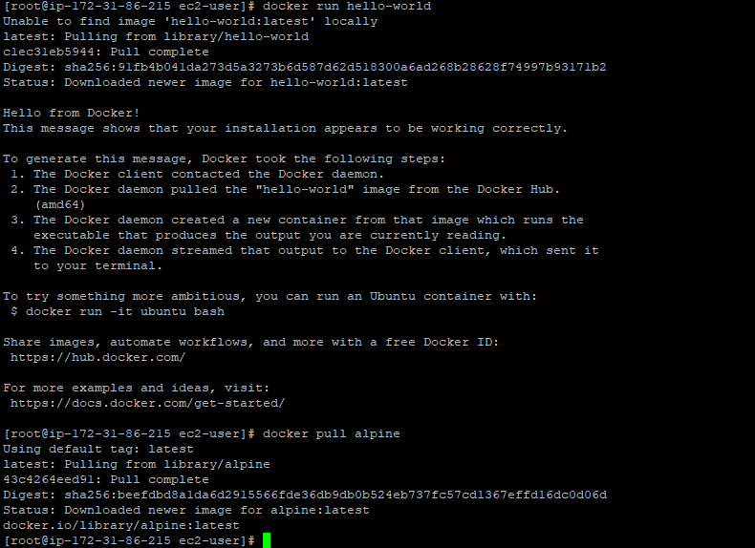

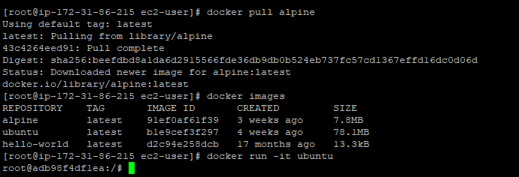

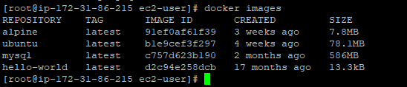

**Conclusion:**

Docker is a software platform that allows you to build, test, and deploy applications quickly. Docker packages software into standardized units called [containers](https://aws.amazon.com/containers/) that have everything the software needs to run including libraries, system tools, code, and runtime. From this experiment, LO5 and PO1, PO2, PO3, PO4, PO5, PO8, PO10, PO12 are achieved.